Coffee with the Professor Penny Gordon-Larsen, PhD, FTOS, FAHA- Ethnicity, Disparities, and Development of Obesity

https://www.eventbrite.com/e/coffee-with-the-professor-penny-gordon-larsen-phd-ftos-faha-tickets-166533362771
ASSOCIATE DEAN FOR RESEARCH
GILLINGS SCHOOL OF GLOBAL PUBLIC HEALTH
CARLA SMITH CHAMBLEE DISTINGUISHED PROFESSOR OF GLOBAL NUTRITION
DEPARTMENT OF NUTRITION

Ethnicity, Disparities, and Development of Obesity
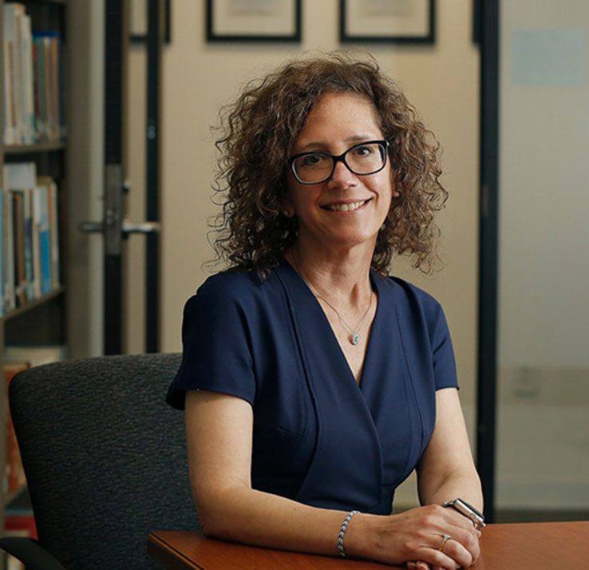

Penny Gordon-Larsen became the Gilling School's Associate Dean for Research in September 2018. In this role, she leads a schoolwide research program of approximately $200 million in research funding each year. She provides intellectual and strategic leadership and vision for research programs and for supporting and enhancing the School’s research enterprise.
Dr. Gordon-Larsen’s research program is supported by the NIH. Much of her research focuses on issues related to ethnicity, disparities and development of obesity over the lifecycle, with attention to pathways linking environment and behavior to cardiometabolic risk. Her portfolio ranges from molecular and genetic to environmental and societal-level factors that influence health. She served as President of The Obesity Society in 2015 and received the Eli Lilly Scientific Achievement Award from The Obesity Society in 2010. She served on the NIH Nutrition Research Thought Leaders Panel and as Chair for the NIH Kidney, Nutrition, Obesity and Diabetes Study Section. She currently serves on the NIH's National Institute of Diabetes and Digestive and Kidney Diseases advisory council and co-chairs the NIDDK's Strategic Plan Dissemination and Implementation Research Subgroup.
She is instrumental in the leadership of COVID-19 research response at the Gillings School. Also, she leads the "Heterogeneity in Obesity Creativity Hub: Transdisciplinary Approaches for Precision Research and Treatment," a large, collaborative project with 27 faculty from 16 departments, six schools and five centers and institutes. The project focuses on understanding why two people who consume the same diets and exercise equally can have very different susceptibility to weight gain, with the aim of developing treatment approaches that go far beyond the “one-size-fits-all” approach that is so common. Read about the Obesity Hub at the UNC Research website.

